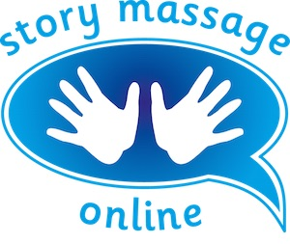
Module 1 – Getting started with the Story Massage Programme
Slide 5
Write down some benefits of the Story Massage Programme.
Physical

Emotional

Social

Educational

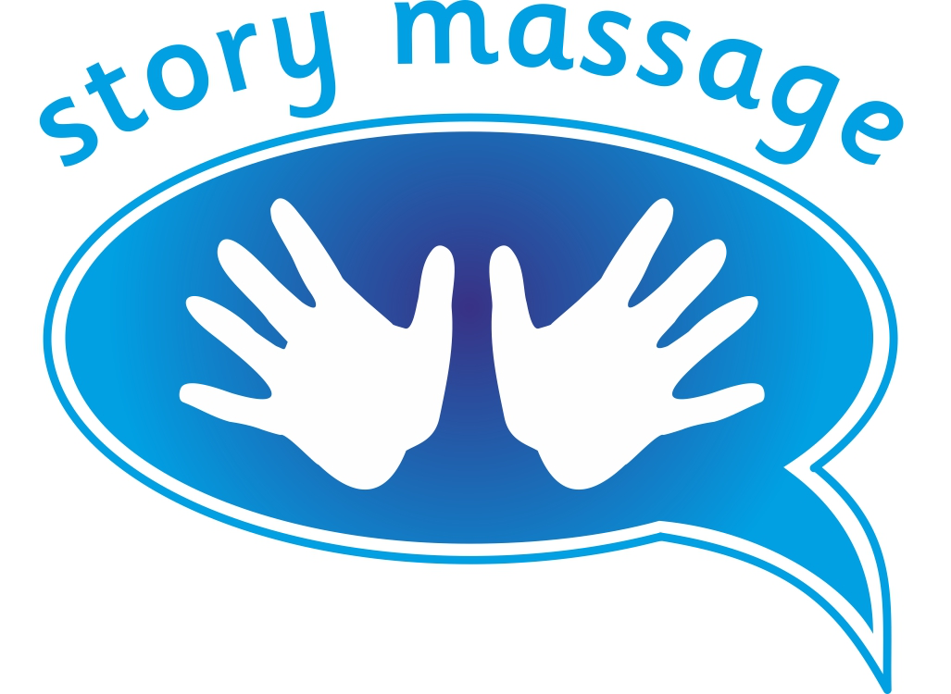© Story Massage Training and Resources
www.storymassage.co.uk

Module 1 – Getting started with the Story Massage Programme
Slide 7
Try to imagine different situations or times of day where you can envisage using the Story Massage Programme – whether at home, school or in the wider community.
Start to make a list here:

© Story Massage Training and Resources
www.storymassage.co.uk

Module 1 – Getting started with the Story Massage Programme
Slide 14
How could the Story Massage Programme be used to celebrate a special occasion or event? Write down some ideas here.

© Story Massage Training and Resources
www.storymassage.co.uk

