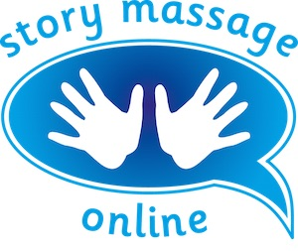
Module 4 – Adapting and creating massage stories
Slide 12
Feedback
The best way to develop a massage story is to give and receive it. When you have written your first draft of a massage story, practice this on someone. And ask them to try it on you too. Work together to answer these questions:
Is the story engaging?

Is the story age appropriate?

Does the massage flow?

Do the strokes illustrate the words?

Could it be improved?

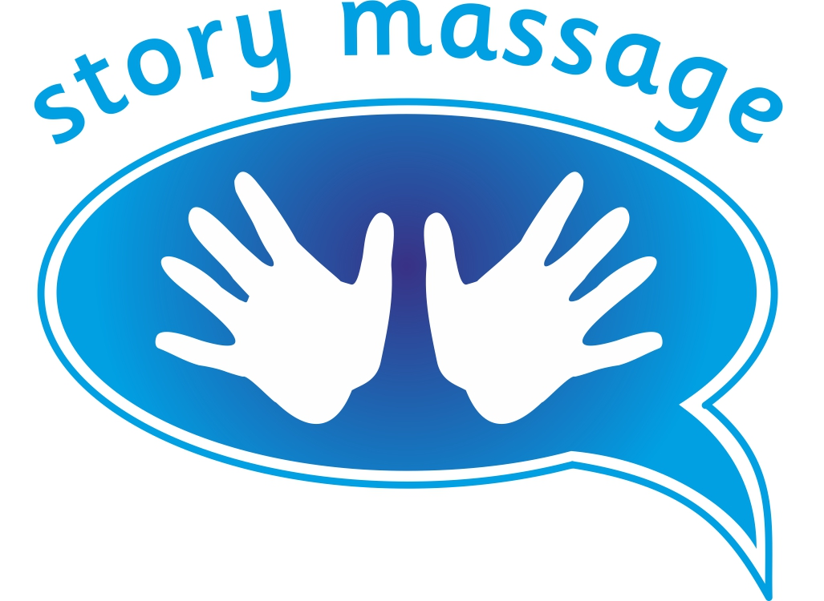© Story Massage Training and Resources
www.storymassage.co.uk
Module 4 – Adapting and creating massage stories
Slide 19
Self-reflection
How did you feel about writing a massage story? Did you enjoy being creative? Did you find it easy or difficult?

Did you prefer working from the scripts in the book?

Did you enjoy working with children or adults to come up with ideas? Think of three things that pleased or surprised you about how others approach the Story Massage Programme.

© Story Massage Training and Resources
www.storymassage.co.uk
Module 4 – Adapting and creating massage stories
Slide 20
Homework
Now you have written and tried some massage stories, reflect on the benefits for those with whom you are currently sharing it and possible ways you could use it in the future.

Think of four specific benefits that you have noticed during the course so far. Are these different to those you wrote down in Module 1?

Consider ways you could develop the Story Massage Programme in your family, place of work. Have these changed during the course? Have you had any new ideas?

© Story Massage Training and Resources
www.storymassage.co.uk

