Module 5 – Making the Story Massage Programme work for you
Name:
Date:
Job title and place of work (if relevant):
Slide 13
To complete the course and receive your certificate, please send your answers to these questions plus an example of a massage story that you have adapted or created to: info@storymassage.co.uk
- Please tick that have read and understood the guidelines for best practice.

- Where are you planning to use the Story Massage Programme?

- What do you consider to be the main benefits of the Story Massage Programme?

- What has been the most personal learning experience of the course?

- What did you like about the course and what parts did you like least?

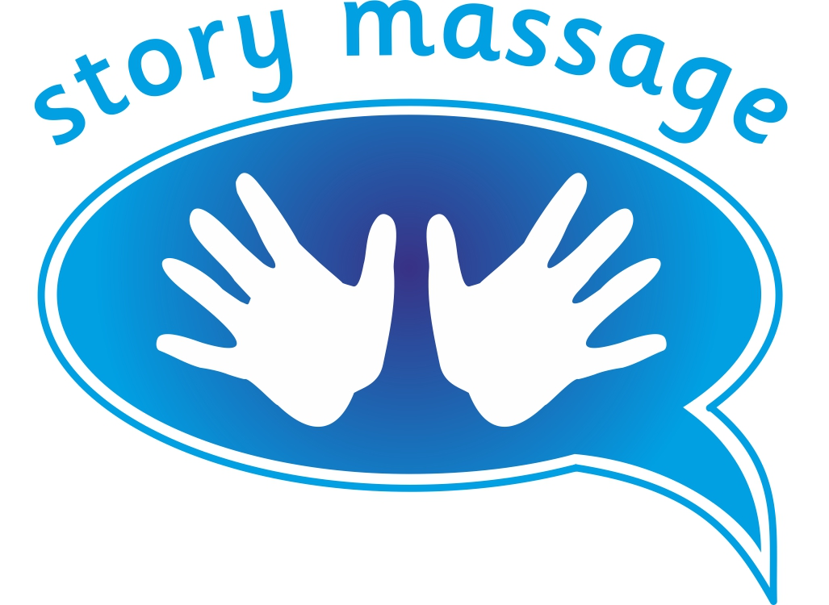© Story Massage Training and Resources
www.storymassage.co.uk

