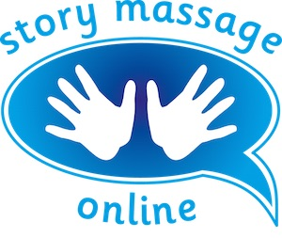
Module 2 – The ten Story Massage strokes
Slide 3
Inspiration - The Circle
Objects:

Actions:

Emotions:

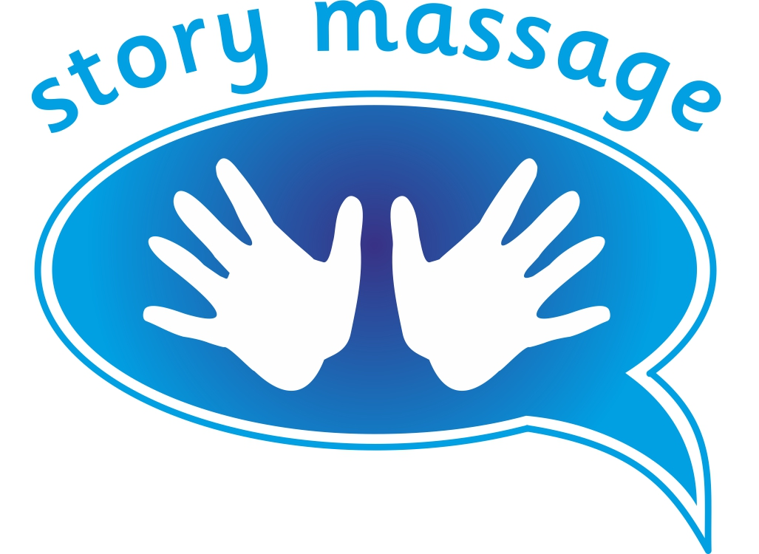© Story Massage Training and Resources
www.storymassage.co.uk
Module 2 – The ten Story Massage strokes
Slide 5
Inspiration - The Wave
Objects:
Actions:

Emotions:

© Story Massage Training and Resources
www.storymassage.co.uk
Module 2 – The ten Story Massage strokes
Slide 7
Inspiration - The Fan

Objects:

Actions:

Emotions:

© Story Massage Training and Resources
www.storymassage.co.uk
Module 2 – The ten Story Massage strokes
Slide 9
Inspiration - The Walk

Objects:
Actions:
Emotions:

© Story Massage Training and Resources
www.storymassage.co.uk
Module 2 – The ten Story Massage strokes
Slide 11
Inspiration - The Drum
Objects:
Actions:

Emotions:

© Story Massage Training and Resources
www.storymassage.co.uk
Module 2 – The ten Story Massage strokes
Slide 13
Inspiration - The Claw

Objects:
Actions:
Emotions:

© Story Massage Training and Resources
www.storymassage.co.uk
Module 2 – The ten Story Massage strokes
Slide 15
Inspiration - The Squeeze

Objects:
Actions:
Emotions:

© Story Massage Training and Resources
www.storymassage.co.uk
Module 2 – The ten Story Massage strokes
Slide 17
Inspiration - The Bounce
Objects:
Actions:

Emotions:

© Story Massage Training and Resources
www.storymassage.co.uk
Module 2 – The ten Story Massage strokes
Slide 19
Inspiration - The Sprinkle
Objects:
Actions:

Emotions:

© Story Massage Training and Resources
www.storymassage.co.uk
Module 2 – The ten Story Massage strokes
Slide 21
Inspiration - The Calm

Objects:
Actions:
Emotions:

© Story Massage Training and Resources
www.storymassage.co.uk

