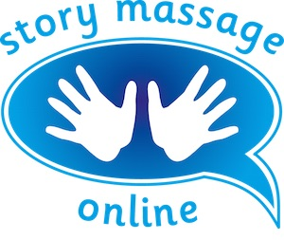
Module 3 – Developing your confidence and skills
Slide 9
Were the words of the massage story interesting and engaging? Did you allow sufficient time to process the words and stimulate their imagination?

Was the experience relaxing and enjoyable? If not, then think about why? Were you nervous? Were you reading a little too fast? Did you forget to do repetitions of the strokes? Were the strokes a bit juddery? This is all perfectly natural when we are learning. The more you practice, the easier it becomes.

What could be improved? Would it be better with a different choice of strokes?

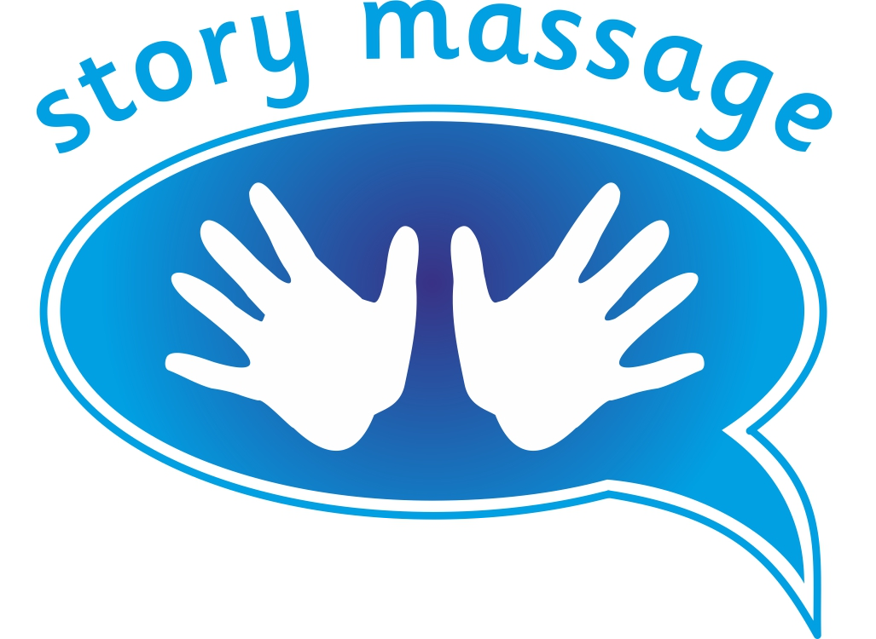© Story Massage Training and Resources
www.storymassage.co.uk
Module 3 – Developing your confidence and skills
Slide 18
Self-reflection
Think about the feedback that you have been given during this module. Write down the three most helpful comments.

Consider where you are planning to share the Story Massage Programme. Are you confident with the guidelines for respectful touch in different settings?

© Story Massage Training and Resources
www.storymassage.co.uk
Module 3 – Developing your confidence and skills
Slide 19
Homework
Choose a massage story from the course book and practice it on a different part of the body – maybe hands, feet, legs, arms or face. How does it feel? Is it easy to adapt the strokes?

Get a few friends/colleagues together and explore the difference between sharing massage stories as a one-to-one activity, and in a circle or a line. Can you see how these might be suitable for different occasions?

© Story Massage Training and Resources
www.storymassage.co.uk

