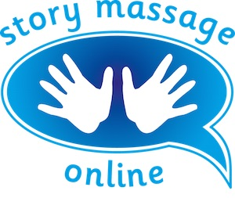
Module 5 – Making the Story Massage Programme work for you
Slide 10
Self-reflection
It is helpful to look back on Module 1 and your initial list of ideas for using the Story Massage Programme. Has this changed throughout the course?

Have you added any new ideas?
Do you already have an individual – young or old – or a group with whom you are planning to use the Story Massage Programme? Start using it as soon as you can. (If you are working outside the home, you may have to wait until your certificate arrives).

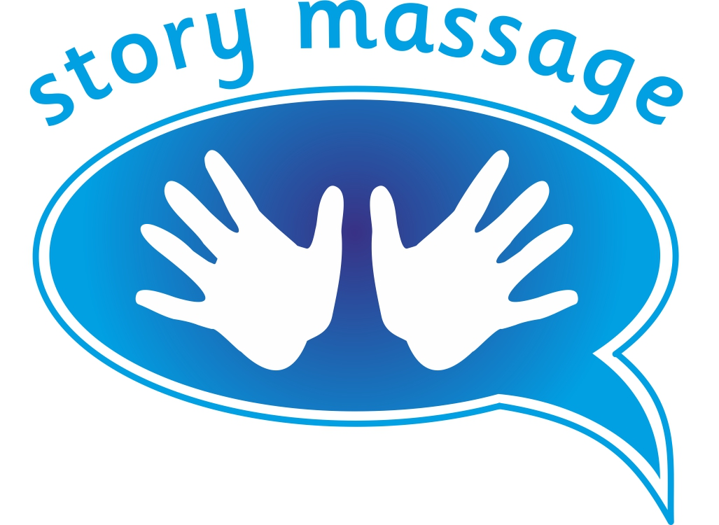© Story Massage Training and Resources
www.storymassage.co.uk
Module 5 – Making the Story Massage Programme work for you
Name:
Date:
Job title and place of work (if relevant):
Slide 13
To complete the course and receive your certificate, please send your answers to these questions plus an example of a massage story that you have adapted or created to: info@storymassage.co.uk
- Please tick that have read and understood the guidelines for best practice.

- Where are you planning to use the Story Massage Programme?

- What do you consider to be the main benefits of the Story Massage Programme?

- What has been the most personal learning experience of the course?

- What did you like about the course and what parts did you like least?

© Story Massage Training and Resources
www.storymassage.co.uk

