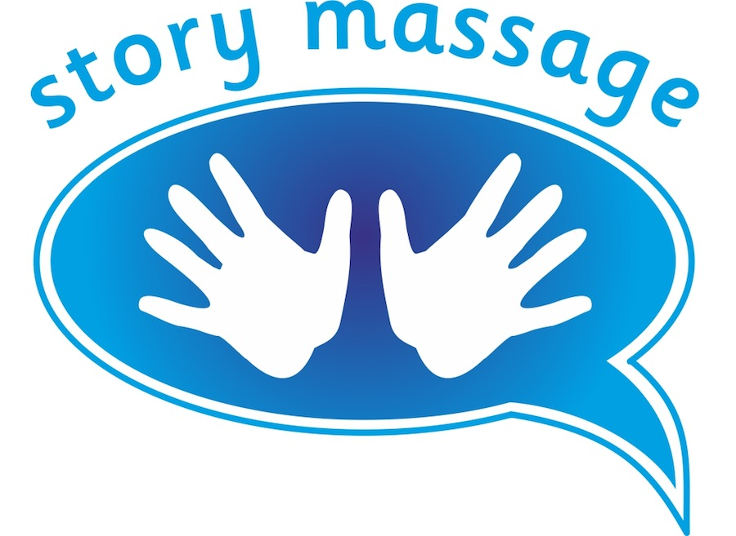

Story Massage Programme

Centre of Excellence Award

Name of Centre:
Best email to use:
Names of those trained in the Story Massage Programme (with place and date of training – or online)

Please let us know your job titles and where you are using the Story Massage Programme.

Specific benefits that you have noticed for the children/adults that you are working with.

One example/case study to show that the Story Massage Programme has made a difference to a child/adult or group of children/adults. Please include the massage story that you used. We may choose to feature this on our blog so permission may be needed.

How do you structure your Story Massage sessions? Is there any advice that you would give to others?

Please return this form to: bestpractice@storymassage.co.uk by 1st June 2023. And please attach any photos/videos that you have permission for us to share on our blog and social media. It is fine to have shots of backs of heads!

